**DESIGN AND DEVELOPMENT OF A PERSONAL PORTFOLIO WEBSITE**

**Table of Contents**

1. Introduction 3

2. Project Objectives 3

3. Planning and Requirement Analysis 4

4. Website Structure and Layout 4

5. Design and Styling Decisions 7

6. Testing and Validation 10

7. Challenges Faced 10

8. Future Improvements 11

9. Conclusion 11

10. References 13

# 1. Introduction

In today's economy, having a digital presence showing background and skills is essential in a competitive job market. This project is a personal portfolio in website form made using basic web technologies like **HTML** and **CSS**. The Portfolio contains the educational background, personal profile, skills, and work experience of **Jashandeep Kaur,** an upcoming student of computer science and a customer service professional. The website also offers a digital resume (CV) embedded with an interactive button.

The goal of the project is to create a portfolio that is straightforward, responsive, user-friendly, and gives essential personal and academic details in a professional design. HTML organises content, while CSS creates layout, styling, and interactivity for web pages. The project is lightweight and compatible with all browsers and different devices.

# 2. Project Objectives

This project aimed at designing and developing a personal portfolio website for a student using basic web technologies such as HTML and CSS. The objective was to develop an attractive as well as professional website that helps exhibit the students’ academics, technical skills and work experience. A website acts as a resume for students that provides a glimpse of their profile to the employer or institution.

A key feature of the website includes a downloadable/viewable PDF CV. This enables anyone visiting the page to download the student’s CV with ease. The code, according to the clean coding standard and responsive web design, was applied to the project to ensure that it works on various screen types (Sinlae *et al.,* 2024).

Another key objective was to mimic the construction of a genuine branding tool that might help the learner get internships, part-time jobs or even a job. This portfolio, which merges curated content with modern design, serves as a practical portfolio that shows off my technical skills in front-end web development and hiring power. This exercise builds your foundation as a web developer and highlights the importance of representing oneself in a digital age.

# 3. Planning and Requirement Analysis

Before starting to develop a personal portfolio website, a planning stage was executed to gather requirements and establish design priorities. It was essential to keep the project focused, organised, and on target to serve its purpose.

The first stage involved content collection. All required information was taken from the existing CV of Jashandeep Kaur. They organised the information into various sections like All personal Information which includes Name, Address, Email, LinkedIn, Gender, Country and many more. The academic history was documented, specifying qualifications obtained from recognised institutions (Foong *et al.,* 2021). The skills section will showcase soft and tech skills, and the work experience section will detail your past employment, which in this case was McDonald’s in Barnala. Also, the CV was included together with the PDF link that can be accessed on the website.

Identifying the target users was another crucial step in planning. This portfolio targets university admissions officers, prospective employers, academic instructors, and professional evaluators. Typically, these users want to assess the applicant's credentials and capacity as well as their presentation skills. This informed the choice of content structure and layout.

Finally, they settled on what tools and technologies they’ll be using. HTML5 for the proper structuring of the content's semantics and CSS3 for controlling the visual design of the website. To improve font types and readability features, Google Fonts were integrated (Tiwari, 2021). Testing and previewed it on Google Chrome, Mozilla Firefox, and Microsoft Edge web browsers to check the compatibility.

The draft plan helped to create a foundation for the development stage. The project will fulfil the technical and user requirements. It facilitated the effective implementation of the design and helped to have a better understanding of the way to align the website with the professional goals of the student.

# 4. Website Structure and Layout

The portfolio website is organised into several semantic sections for clarity, consistency, and easy navigation for users. Each part of the website has a distinct purpose, which depicts professionalism on the website.

The **header** is at the top of the page, displaying the user's full name, “Jashandeep Kaur.” Moreover, it also has subtitles describing the user as an aspiring professional. Thus, it gives the visitor an impression instantly. The website’s tone is set, and the human being is introduced in a sharp and business-like manner.

After the header comes the **contact info section** that mentions your address, email ID, LinkedIn, gender, date of birth and nationality. These details are written in clean typography to make them easy to read (Rao, Chaurasia and Singh, 2023). A clean layout without icons clearly distinguishes information in the present version to enhance the user experience.

Jashandeep’s **“About Me” section** provides a short yet meaningful overview of one’s motivation, values, and aspirations. It is a personal introduction to her personality that gives insight to visitors apart from her qualifications and experience. It adds a personal touch to the portfolio by communicating excitement to learn, flexibility to adapt, with the aim of growing within a work environment (Kalaitzopoulou et al., 2023). It helps to form a bond with the reader, making the profile more relatable and memorable.

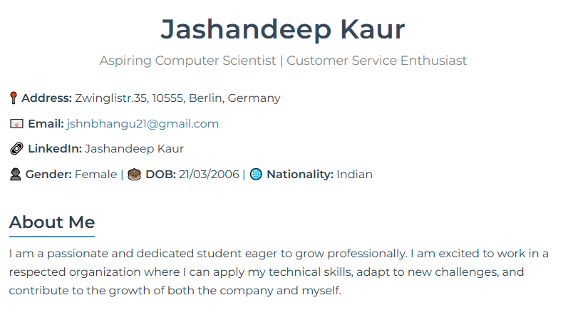

**Figure 1: Website**

(Source: self-created)

The **Education section** is organised in a logical way to show the academic history of Jashandeep in a specific manner, that is, in reverse chronology. Every scholastic listing contains the name of the institution, the place where it is located, the credentials acquired, and the commencement or completion date. This organisation makes sure that it is easy to evaluate her educational progress and the stage she is in (Rose, Macdonald and Putnam, 2022). It shows her educational experience in India in a secondary school and in Germany at a university, where she found the foundation of her objectives as a professional in the field of computer science.

The **skills section** of the portfolio website is carefully designed to emphasise Jashandeep’s key technical and soft skills in a visually appealing and organised manner. Instead of listing skills in plain text, they are displayed in a “badge” or “chip” style format using CSS styling. Each skill is enclosed in a colored, rounded box that stands out from the rest of the content, creating a clean and modern look. This layout not only enhances the aesthetic appeal of the website but also improves readability and scanability, especially for recruiters or academic reviewers who are quickly assessing a candidate’s strengths (Chen, 2025). Using a flexbox ensures that the badges are responsive and neatly arranged across different screen sizes.

The **work experience section** provides a concise summary of Jashandeep’s previous role as a restaurant server at McDonald’s in Handiaya (Barnala). The content outlines key responsibilities such as maintaining the cleanliness of dining areas, greeting and serving customers, taking orders, and resolving customer concerns. These tasks are presented in bullet points for clarity and professionalism. By including this information, the website demonstrates her hands-on experience in customer service, highlighting essential attributes like communication, responsibility, and adaptability—traits that are valuable in both technical and non-technical roles.

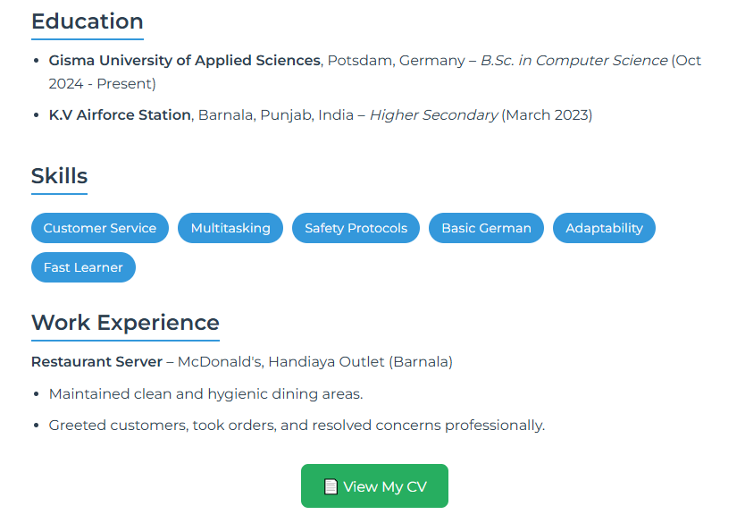

**Figure 2: Website**

(Source: self-created)

Finally, the **CV button** is located at the bottom of the page, and it has been designed in a way that is easy to notice. This feature enables the user of the button to have the attached PDF CV opened in a new browser tab, thus immediately accessing it without downloading the file. It makes the portfolio more functional and useful as a work tool in professional life.

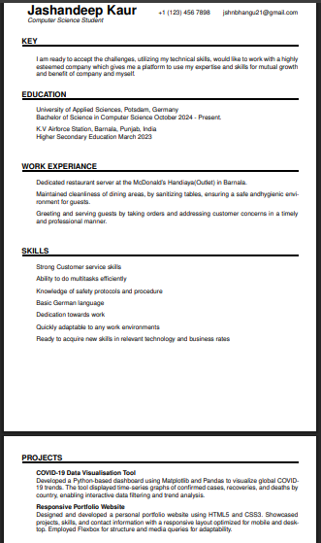

**Figure 3: CV**

(Source: self-created)

# 5. Design and Styling Decisions

The graphical layout of the portfolio site is very important in providing professional and familiar experience to the user. Visual impressiveness was created with **CSS3**, taking advantage of colour theory, font hierarchy, spaces, layout composition, and soft visuals using shadows and transition effects. All these make the site more usable and appealing so that it creates a lasting impression on the viewers, like the recruiters or even the academic reviewers.

**Typography**

Typography is one of the main features of the design. To create a modern, clean, professional tone, the site applies to the **Montserrat** typeface, which has been imported to the site via Google fonts. The reason why this font was considered is that it is easily readable and looks rather elegant on different gadgets. The font types are also used to distinguish between different types of content. The main parts are distinguished by bold headings and catch the attention, subtitles are semi-bold, and the text content between the three parts is written with less impact (Villani et al., 2021). This tree structure makes sure that users can skim the content or search for the information they want with no effort at all.

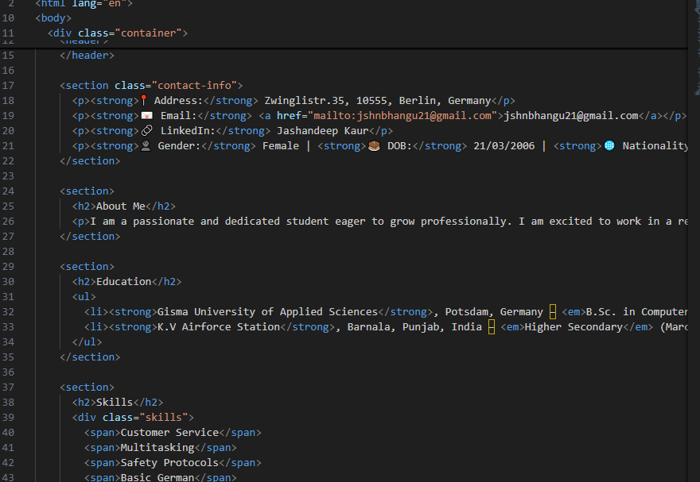

**Figure 4: Code**

(Source: self-created)

**Color Scheme**

The colour palette of the website is subtle yet effective. The background features a **soft blue-green gradient** transitioning from #f0f4f8 to #e9eff5, providing a calm and clean visual backdrop. This helps the white content cards stand out while maintaining a soft overall appearance. The primary text colour, #2c3e50, ensures excellent contrast against the background for clear readability. Accent colours such as #3498db (blue) and #27ae60 (green) are used strategically for links, section headings, and buttons to guide the user’s attention and provide a polished look.

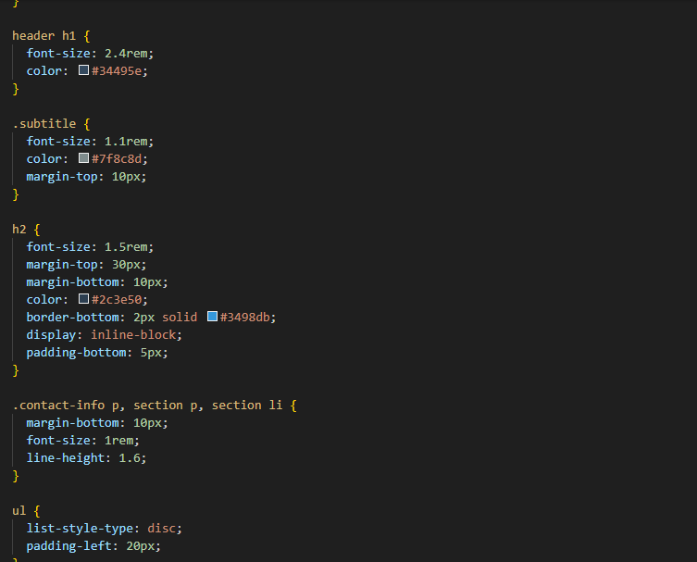

**Figure 5: Code**

(Source: self-created)

**Layout and Responsiveness**

The layout uses a centred container with maximum width and consistent padding to create a balanced and spacious reading environment. **CSS properties such as box-shadow and border-radius** are applied to sections and cards to add depth and visual separation between content blocks. Although the design is desktop-first, **basic responsiveness** is implemented using flexible layouts and flex-wrap on skill badges, allowing them to adapt to smaller screen sizes without breaking the layout.

**Buttons and Interaction**

To enhance interactivity, the **“View My CV” button** is styled with a green background (#27ae60) and includes a hover effect that transitions the colour to a darker shade (#219150). This subtle animation, enabled through **CSS transitions**, provides immediate visual feedback to users, encouraging interaction and improving the overall user experience.

# 6. Testing and Validation

To ensure the portfolio website works fine and gives good user experience, it was tested thoroughly in several areas. It was important to test the site in different environments to verify usability, accessibility, and code quality.

The testing phase presented challenges surrounding the compatibility of different browsers. They tried the web on all the famous modern web browsers such as Chrome, Firefox, and Edge. In all tested cases, the site displayed consistently, with no layout faults or broken styles. The CSS and HTML code were uniformly interpreted across platforms. Therefore, users will have consistent experience no matter which browser they prefer using.

The integration of CV was verified with respect to **file access** by placing the PDF file in the same folder as index.html. When the "View My CV" button is clicked, it opens the PDF in a new browser tab, as it is supposed to (Gur et al., 2023). This method allows users to have access to the CV right at the click without the need for downloading or any plugins.

**Accessibility** was also a key consideration. The colour combinations were created with high contrast for better visibility for the users. Keep the font size readable against various screen resolutions. The use of tags like <header>, <section>, <ul>, and other semantic HTML will ensure compatibility with screen readers and assistive technology.

Finally, the W3C validation services were used for **code validation**. Both the HTML and CSS files were checked to confirm their compliance with current web standards. The validation process showed no major errors, meaning that the site was built on clean, standards-compliant code. As a result, it’s going to make the site more reliable. Plus, it will future-proof it with web technologies (Akimov et al, 2021).

Overall, the website passed all essential tests, confirming its robustness and readiness for real-world use.

# 7. Challenges Faced

In the process of creating the portfolio site, there were some problems encountered, and some solutions needed to be carefully worked out, especially in the field of adaptations.

Among the main challenges was the **styling of the layout**. This was a challenging task using the current design across every browser, as it was not possible using a ready-made CSS framework, such as Bootstrap. Alignment problems were initially caused by differences in the implementation of spacing, padding and box models by browsers. These were addressed using a consistent box-sizing property as well as balancing of the margin and padding to result in a balanced layout.

**Integration of the CV file** was another problem. First, it was planned to render the PDF using an <iframe>, but this solution led to a cross-browser and cross-device inconsistent rendering. To prevent loss of this cross-browser compatibility and to make it easier to access, this CV was rather anchored via an anchor tag in which the attribute target="_blank" was used so that the file should be opened in separate window or browser tab without interfering or consuming the layout and functionality of the parent site.

Lastly, during testing, font **rendering irregularities** were noticed. Though the Montserrat font by Google Fonts performed appropriately in most instances, the use of different browsers resulted in minor disparities in the form of font weight and spacing. In mitigation of this, fallback fonts like sans-serif fonts were introduced in the CSS font stack just to give assurance that the text could be read and could look visually complementary in all viewing platforms.

# 8. Future Improvements

Even though the website is functional and working as intended, there are a few useful improvements that could be made to future versions of the website to make it more user-friendly and professional. CSS media queries, through which responsive design could be implemented, would be one enhancement. This would guarantee a perfect show across mobile devices and tablets to enhance access. Also, using JavaScript integration can improve the user experience by adding dark mode as an option or a smooth scrolling animation. Including a section for a professional profile photo would enhance the site’s personality and visual engagement (Krevor *et al.,* 2023). Moreover, a contact form would help visitors to contact the site directly. This form can use JavaScript for power and can be supported with the help of PHP or Node.js as a backend for message handling. These improvements combined would make the portfolio more dynamic, interactive and fit for real-world professionals.

# 9. Conclusion

Working on this project gave me great hands-on experience in fundamental web development while developing a portfolio website for Jashandeep Kaur using HTML and CSS. The website presents her education, skills, and professional experience in an orderly manner. Moreover, the option to download her CV. The design embodies a professional, simple and modern look to enhance usability. The project achieved all its initial goals by showcasing the basic ideas behind front-end development. It is a good launching pad for more learning, as well as web design and personal branding.

# 10. References

Sinlae, F., Sitorus, A.B., Setiawan, F. and Fajar, A., 2024. Pelatihan dan Pembuatan Website Portofolio Sederhana Untuk Peningkatan Kemampuan Mahasiswa. *J. Ilmu Multidisiplin*, *3*(2), pp.165-172.

Foong, E., Kim, J.O., Dontcheva, M. and Gerber, E.M., 2021. CrowdFolio: Understanding How Holistic and Decomposed Workflows Influence Feedback on Online Portfolios. *Proceedings of the ACM on Human-Computer Interaction*, *5*(CSCW1), pp.1-31.

Tiwari, S., 2021. Designing a Personal Website for Identity Building and Career Growth for PhD Students. *TechTrends*, *65*(4), pp.413-417.

Rao, P.R., Chaurasia, A.K. and Singh, S.P., 2023. Modern web design: Utilizing HTML5, CSS3, and responsive techniques. *The International Journal of Research and Innovation in Dynamics of Engineering*, *1*(8), pp.a1-a18.

Kalaitzopoulou, E., Matthews, P., Mystakidis, S. and Christopoulos, A., 2023. Engagement with optional formative feedback in a portfolio-based digital design module. *Information*, *14*(5), p.287.

Rose, E.J., Macdonald, C.M. and Putnam, C., 2022, October. Teaching Design Systems: Towards a flexible and scalable model for the UX classroom. In *Proceedings of the 40th ACM International Conference on Design of Communication* (pp. 107-113).

Chen, Z., 2025. Revolutionizing finance with conversational AI: a focus on ChatGPT implementation and challenges. *Humanities and Social Sciences Communications*, *12*(1), pp.1-11.

Villani, L., Pastorino, R., Molinari, E., Anelli, F., Ricciardi, W., Graffigna, G. and Boccia, S., 2021. Impact of the COVID-19 pandemic on psychological well-being of students in an Italian university: a web-based cross-sectional survey. *Globalization and health*, *17*, pp.1-14.

Gur, I., Furuta, H., Huang, A., Safdari, M., Matsuo, Y., Eck, D. and Faust, A., 2023. A real-world webagent with planning, long context understanding, and program synthesis. *arXiv preprint arXiv:2307.12856*.

Akimov, O., Karpa, M., Parkhomenko-Kutsevil, O., Kupriichuk, V. and Omarov, A., 2021. Entrepreneurship education of the formation of the e-commerce managers professional qualities. *International Journal of Entrepreneurship*, *25*(7), pp.1-8.

Krevor, S., De Coninck, H., Gasda, S.E., Ghaleigh, N.S., de Gooyert, V., Hajibeygi, H., Juanes, R., Neufeld, J., Roberts, J.J. and Swennenhuis, F., 2023. Subsurface carbon dioxide and hydrogen storage for a sustainable energy future. *Nature Reviews Earth & Environment*, *4*(2), pp.102-118.